# Document Contents:

* Sample Posts for LinkedIn and Facebook
* Sample Posts for Twitter (X) and Threads
* Relevant Hashtags
* Sample Images

# Sample Posts for LinkedIn and Facebook:

Please update to fit your company details before sharing with your audience.

*[COMPANY NAME]* is proud to share that we have successfully completed a SOC 1 examination.

Performed by @BARR Advisory, P.A., the exam demonstrates the effectiveness of the controls we’ve put in place to ensure the integrity of data within our systems relevant to users’ financial reporting. Read our latest blog post to learn more: *[INSERT LINK TO CORRESPONDING BLOG POST]*

It’s official: We completed a System and Organization Controls (SOC) 1 examination in partnership with @BARR Advisory, P.A.! The resulting report indicates we have maintained effective internal controls to ensure the integrity of data within our systems relevant to users’ financial reporting.

Learn more about why we chose to undergo this rigorous compliance audit and what it means for you: *[INSERT LINK TO CORRESPONDING BLOG POST]*

@BARR Advisory, P.A. recently conducted a System and Organization Controls (SOC) 1 examination assessing the effectiveness of *[COMPANY NAME]*’s internal controls relevant to user entities’ financial reporting.

Learn more about why we chose to undergo this rigorous compliance audit: *[INSERT LINK TO CORRESPONDING BLOG POST]*

It’s official! We just received our latest SOC 1 report from our auditor, @BARR Advisory, P.A.

Congrats to our team, and to our valued customers who can feel confident in our commitment to delivering a high-quality, secure experience to our clients. Learn more: *[INSERT LINK TO CORRESPONDING BLOG POST]*

# Sample Posts for Twitter (X) and Threads:

Please update to fit your company details before sharing with your audience.

*[COMPANY NAME]* is proud to share that we have successfully completed a SOC 1 examination. This achievement exemplifies our commitment to delivering a high-quality, trustworthy experience to our clients.

Read our latest blog post to learn more: *[INSERT LINK TO CORRESPONDING BLOG POST]*

It’s official: We completed a SOC 1 exam! The resulting report indicates we have designed effective internal controls to ensure the integrity of data within our systems relevant to users’ financial reporting.

Learn more: *[INSERT LINK TO CORRESPONDING BLOG POST]*

[COMPANY NAME] is committed to delivering a high-quality, secure experience to our clients. That’s why we worked with @BARRadvisory to complete a SOC 1 report.

Learn more: *[INSERT LINK TO CORRESPONDING BLOG POST]*

It’s official! We just received our latest SOC 1 report from our auditor, @BARRadvisory.

Congrats to our team, and to our valued customers who can feel confident in our commitment to delivering a high-quality, secure experience to our clients.

Learn more: *[INSERT LINK TO CORRESPONDING BLOG POST]*

# Relevant Hashtags to Consider Including in Your Post(s):

#SOC

#SOC1

#FinancialReporting

#DataProtection

#SOCcompliance

#Compliance

#CloudSecurity

#RaiseTheBARR

# 

# Sample Images:

Click to download.

[](https://www.barradvisory.com/wp-content/uploads/2023/08/SOCPromoPackage_Image2.png) [](https://www.barradvisory.com/wp-content/uploads/2023/08/SOCPromoPackage_Image1.png) [](https://www.barradvisory.com/wp-content/uploads/2023/08/SOCPromoPackage_Image3.png)

[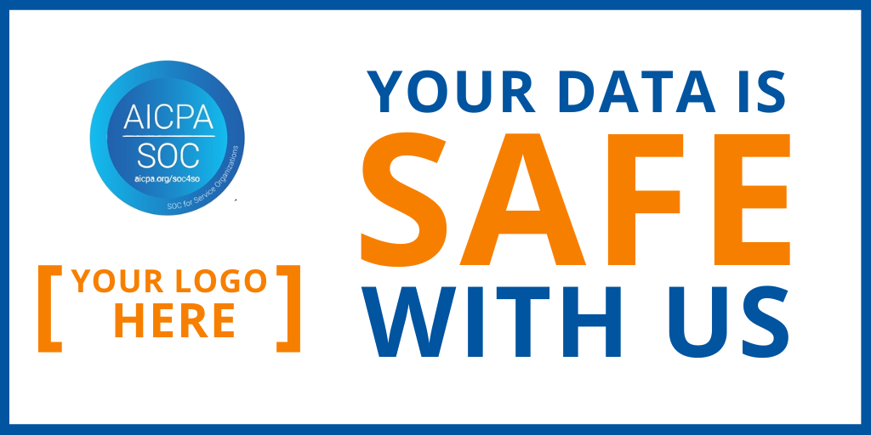](https://www.barradvisory.com/wp-content/uploads/2023/08/SOCPromoPackage_Image4_Landscape.png)

[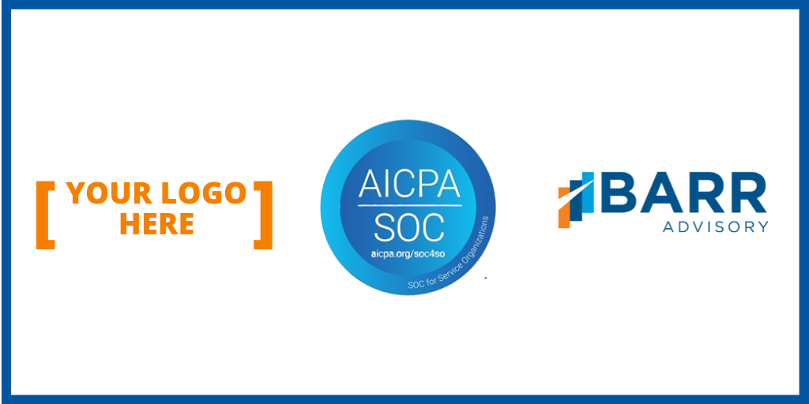](https://www.barradvisory.com/wp-content/uploads/2023/08/SOCPromoPackage_Image5_Landscape.png)