# Document Contents:

* Sample Posts for LinkedIn and Facebook
* Sample Posts for Twitter (X) and Threads
* Relevant Hashtags
* Sample Images

# 

# Sample Posts for LinkedIn and Facebook:

Please update to fit your company details before sharing with your audience.

Your data is safe with us. And we have the SOC 2 and SOC 3 reports to prove it.

@BARR Advisory, P.A. recently conducted a thorough examination assessing the effectiveness of *[COMPANY NAME]*’s controls surrounding *[INCLUDE ONLY APPLICABLE TRUST SERVICES CRITERIA: security, availability, processing integrity, confidentiality, and/or privacy]*. The resulting reports demonstrate our commitment to sound cybersecurity practices.

Learn more about why we chose to undergo this rigorous compliance audit: *[INSERT LINK TO CORRESPONDING BLOG POST]*

What’s the best way for a company to prove it’s taking the steps necessary to keep customer data safe? With System and Organization Controls (SOC) 2 and SOC 3 reports.

We’re proud to announce that we worked with @BARR Advisory, P.A. to complete our latest compliance examination.

Learn more: *[INSERT LINK TO CORRESPONDING BLOG POST]*

*[COMPANY NAME]* is proud to share that we worked with @BARR Advisory, P.A. to complete a thorough compliance audit.

Our SOC 2 and SOC 3 reports show that *[COMPANY NAME]* has designed and maintained effective controls over the *[INCLUDE ONLY APPLICABLE TRUST SERVICES CRITERIA: security, availability, processing integrity, confidentiality, and/or privacy]* of our online platforms.

In other words, you can rest easy knowing your data is safe with us.

Read our latest blog post to learn more: *[INSERT LINK TO CORRESPONDING BLOG POST]*

[COMPANY NAME] is committed to keeping customer data safe. That’s why we worked with @BARR Advisory, P.A. to complete a thorough examination of our *[INCLUDE ONLY APPLICABLE TRUST SERVICES CRITERIA: security, availability, processing integrity, confidentiality, and/or privacy]* controls.

Learn more about why we chose to undergo this rigorous compliance audit and what it means for you: *[INSERT LINK TO CORRESPONDING BLOG POST]*

It’s official: We have received our latest SOC 2 and SOC 3 reports from @BARR Advisory, P.A.! The reports indicate we have maintained effective controls over the *[INCLUDE ONLY APPLICABLE TRUST SERVICES CRITERIA: security, availability, processing integrity, confidentiality, and/or privacy]* of our online platforms.

Translation: Your data is safe with us.

It’s official! We just received our latest SOC 2 and SOC 3 reports from our auditor, @BARR Advisory, P.A.

Congrats to our team, and to our valued customers who can rest assured data is safe with us. Learn more: *[INSERT LINK TO CORRESPONDING BLOG POST]*

# 

# Sample Posts for Twitter (X) and Threads:

Please update to fit your company details before sharing with your audience.

We’re proud to share that our latest SOC 2 and SOC 3 reports indicate we have maintained effective controls over the *[INCLUDE ONLY APPLICABLE TRUST SERVICES CRITERIA: security, availability, processing integrity, confidentiality, and/or privacy]* of our online platforms.

Translation: Your data is safe with us.

What’s the best way for a company to prove it’s taking the steps necessary to keep customer data safe? With SOC 2 and SOC 3 reports. We’re proud to announce we worked with @BARRadvisory to complete a thorough compliance audit.

Learn more: *[INSERT LINK TO CORRESPONDING BLOG POST]*

[COMPANY NAME] is committed to keeping customer data safe. That’s why we worked with @BARRadvisory to complete a thorough examination of our *[INCLUDE ONLY APPLICABLE TRUST SERVICES CRITERIA: security, availability, processing integrity, confidentiality, and/or privacy]* controls.

Learn more: *[INSERT LINK TO CORRESPONDING BLOG POST]*

It’s official! We just received our latest SOC 2 and SOC 3 reports from our auditor, @BARRadvisory.

Congrats to our team, and to our valued customers who can rest assured data is safe with us. Learn more: *[INSERT LINK TO CORRESPONDING BLOG POST]*

Your data is safe with us. And we have the SOC 2 and SOC 3 reports to prove it.

The reports demonstrate the effectiveness of *[COMPANY NAME]*’s controls surrounding *[INCLUDE ONLY APPLICABLE TRUST SERVICES CRITERIA: security, availability, processing integrity, confidentiality, and/or privacy]*.

Learn more: *[INSERT LINK TO CORRESPONDING BLOG POST]*

# Relevant Hashtags to Consider Including in Your Post(s):

#SOC

#SOC2

#SOC3

#SOC2Type1

#SOC2Type2

#SOC2Report

#Cybersecurity

#Security

#InfoSec

#PrivacyControls

#DataProtection

#OnlineSecurity

#SecurityCompliance

#CloudSecurity

#Compliance

#RaiseTheBARR

# 

# Sample Images:

Click to download.

[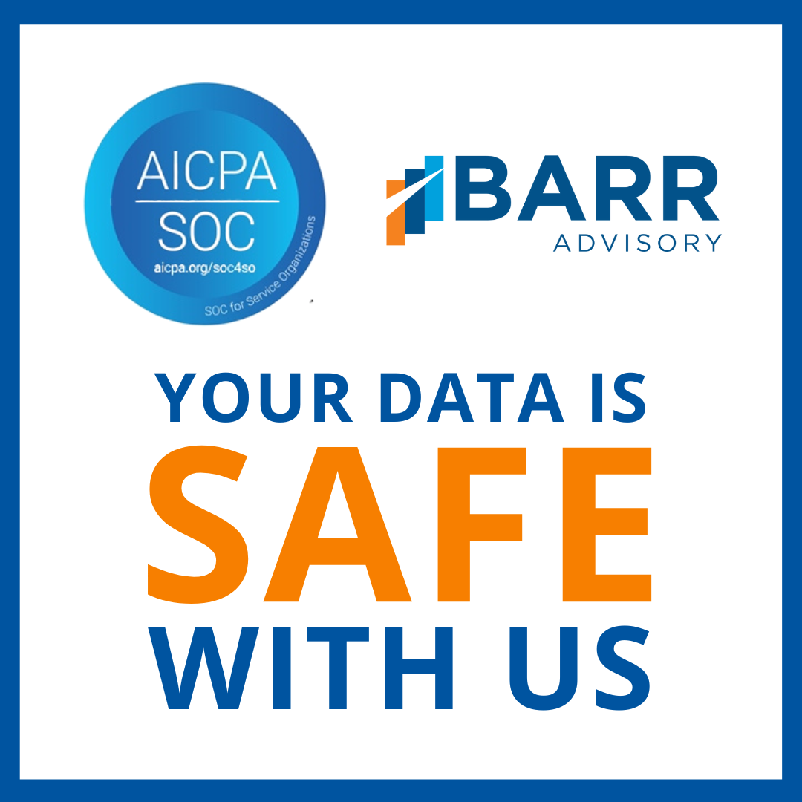](https://www.barradvisory.com/wp-content/uploads/2023/08/SOCPromoPackage_Image2.png) [](https://www.barradvisory.com/wp-content/uploads/2023/08/SOCPromoPackage_Image1.png) [](https://www.barradvisory.com/wp-content/uploads/2023/08/SOCPromoPackage_Image3.png)

[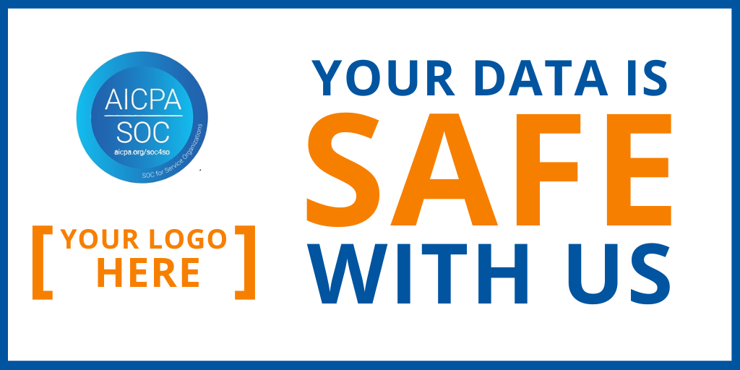](https://www.barradvisory.com/wp-content/uploads/2023/08/SOCPromoPackage_Image4_Landscape.png)

[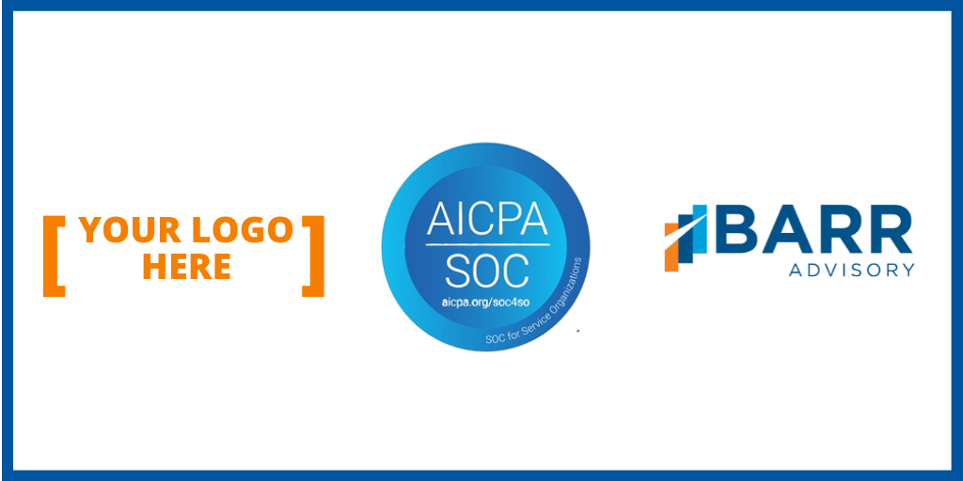](https://www.barradvisory.com/wp-content/uploads/2023/08/SOCPromoPackage_Image5_Landscape.png)