# Document Contents:

* Sample Posts for LinkedIn and Facebook
* Sample Posts for Twitter (X) and Threads
* Relevant Hashtags
* Sample Images

# 

# Sample Posts for LinkedIn and Facebook:

Please update to fit your company details before sharing with your audience.

*[COMPANY NAME]* is proud to share that we have successfully completed a SOC 2 examination.

Performed by @BARR Advisory, P.A., the exam shows that *[COMPANY NAME]* has designed and maintained effective controls over the *[INCLUDE ONLY APPLICABLE TRUST SERVICES CRITERIA: security, availability, processing integrity, confidentiality, and/or privacy]* of our online platforms.

In other words, you can rest easy knowing your data is safe with us.

Read our latest blog post to learn more: *[INSERT LINK TO CORRESPONDING BLOG POST]*

It’s official: We completed a System and Organization Controls (SOC) 2 examination in partnership with BARR Advisory, P.A.! The resulting report indicates we have maintained effective controls over the *[INCLUDE ONLY APPLICABLE TRUST SERVICES CRITERIA: security, availability, processing integrity, confidentiality, and/or privacy]* of our online platforms.

Translation: Your data is safe with us.

Your data is safe with us. And we have the SOC 2 report to prove it.

@BARR Advisory, P.A. recently conducted a System and Organization Controls (SOC) 2 [Type 1/Type 2] examination assessing the effectiveness of *[COMPANY NAME]*’s controls surrounding *[INCLUDE ONLY APPLICABLE TRUST SERVICES CRITERIA: security, availability, processing integrity, confidentiality, and/or privacy]*. The result is a detailed report demonstrating our commitment to sound cybersecurity practices.

Learn more about why we chose to undergo this rigorous compliance audit: *[INSERT LINK TO CORRESPONDING BLOG POST]*

What’s the best way for a company to prove it’s taking the steps necessary to keep customer data safe? By completing a System and Organization Controls (SOC) 2 examination. We’re proud to announce that we worked with @BARR Advisory, P.A. to do just that.

Read on to learn more about what our SOC 2 *[Type 1/Type 2]* report means for you: *[INSERT LINK TO CORRESPONDING BLOG POST]*

[COMPANY NAME] is committed to keeping customer data safe. That’s why we worked with @BARR Advisory, P.A. to complete a thorough examination of our *[INCLUDE ONLY APPLICABLE TRUST SERVICES CRITERIA: security, availability, processing integrity, confidentiality, and/or privacy]* controls.

Learn more about why we chose to undergo this rigorous compliance audit and what it means for you: *[INSERT LINK TO CORRESPONDING BLOG POST]*

It’s official! We just received our latest SOC 2 *[Type 1/Type 2]* report from our auditor, @BARR Advisory, P.A.

Congrats to our team, and to our valued customers who can rest assured data is safe with us. Learn more: *[INSERT LINK TO CORRESPONDING BLOG POST]*

# 

# Sample Posts for Twitter (X) and Threads:

Please update to fit your company details before sharing with your audience.

*[COMPANY NAME]* is proud to share that we have successfully completed a SOC 2 examination. In other words, you can rest easy knowing your data is safe with us.

Read our latest blog post to learn more: *[INSERT LINK TO CORRESPONDING BLOG POST]*

Your data is safe with us. And we have the SOC 2 report to prove it.

@BARRadvisory recently performed a SOC 2 [Type 1/Type 2] examination, resulting in a detailed report demonstrating our commitment to sound cybersecurity practices.

Learn more: *[INSERT LINK TO CORRESPONDING BLOG POST]*

It’s official: We completed a SOC 2 exam with @BARRadvisory! The resulting report indicates we have maintained effective controls over the *[INCLUDE ONLY APPLICABLE TRUST SERVICES CRITERIA: security, availability, processing integrity, confidentiality, and/or privacy]* of our online platforms.

Translation: Your data is safe with us.

What’s the best way for a company to prove it’s taking the steps necessary to keep customer data safe? By completing a SOC 2 exam. We’re proud to announce we worked with @BARRadvisory to do just that. Learn more: *[INSERT LINK TO CORRESPONDING BLOG POST]*

[COMPANY NAME] is committed to keeping customer data safe. That’s why we worked with @BARRadvisory to complete a thorough examination of our *[INCLUDE ONLY APPLICABLE TRUST SERVICES CRITERIA: security, availability, processing integrity, confidentiality, and/or privacy]* controls. Learn more: *[INSERT LINK TO CORRESPONDING BLOG POST]*

It’s official! We just received our latest SOC 2 *[Type 1/Type 2]* report from our auditor, @BARRadvisory.

Congrats to our team, and to our valued customers who can rest assured data is safe with us. Learn more: *[INSERT LINK TO CORRESPONDING BLOG POST]*

# Relevant Hashtags to Consider Including in Your Post(s):

#SOC

#SOC2

#SOC2Type1

#SOC2Type2

#SOC2Report

#Cybersecurity

#Security

#InfoSec

#PrivacyControls

#DataProtection

#OnlineSecurity

#SecurityCompliance

#CloudSecurity

#RaiseTheBARR

# 

# Sample Images:

Click to download.

[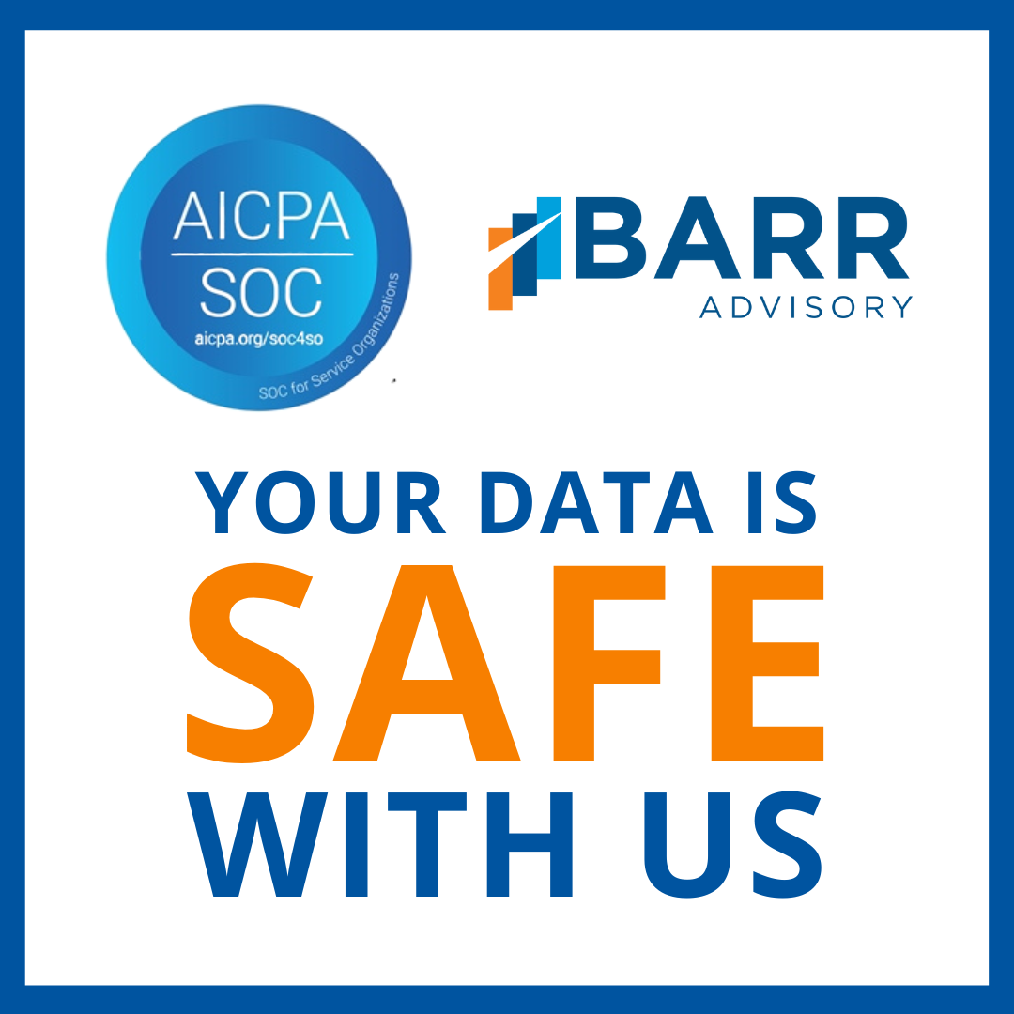](https://www.barradvisory.com/wp-content/uploads/2023/08/SOCPromoPackage_Image2.png) [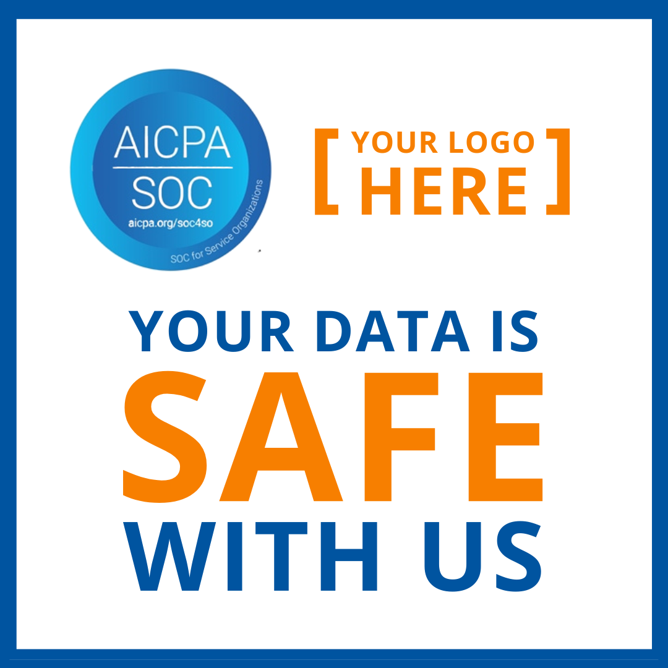](https://www.barradvisory.com/wp-content/uploads/2023/08/SOCPromoPackage_Image1.png) [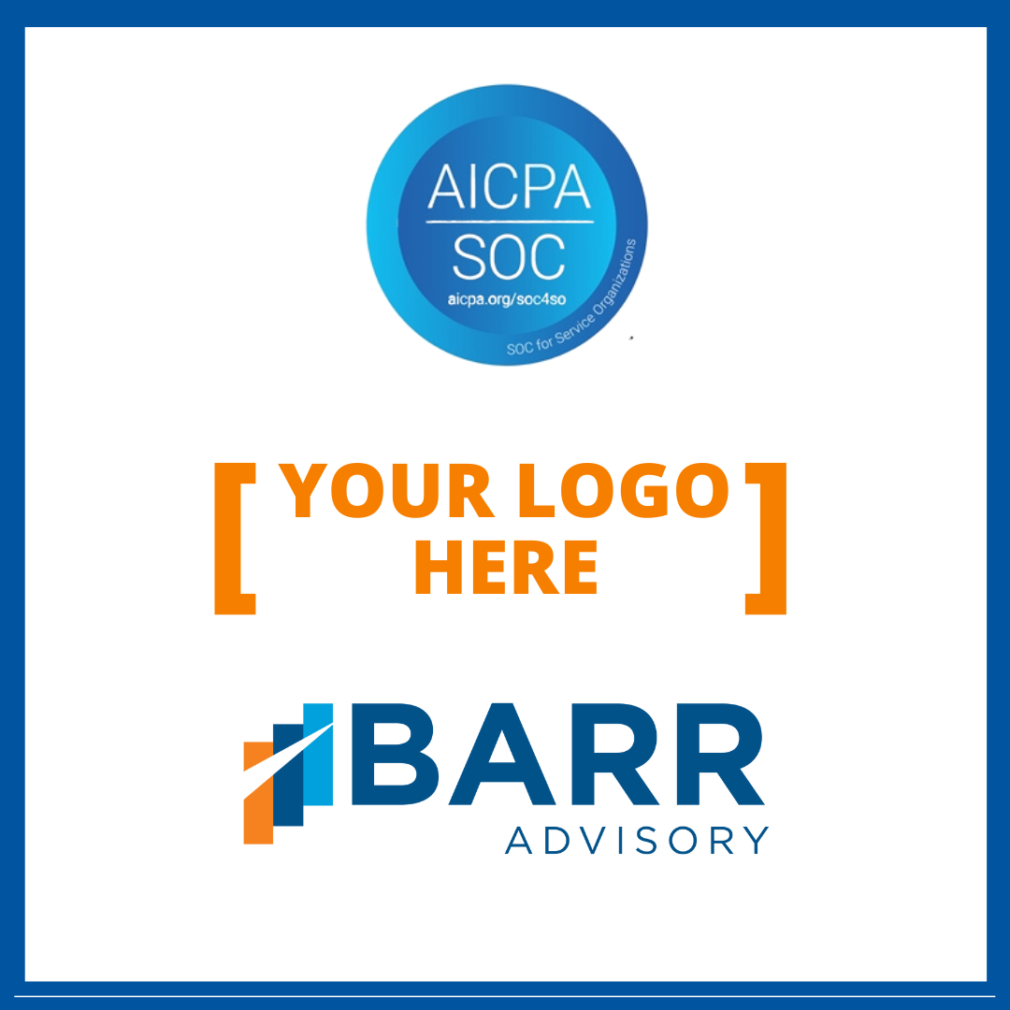](https://www.barradvisory.com/wp-content/uploads/2023/08/SOCPromoPackage_Image3.png)

[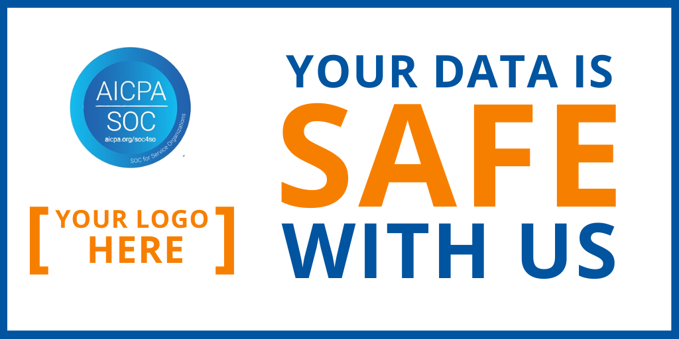](https://www.barradvisory.com/wp-content/uploads/2023/08/SOCPromoPackage_Image4_Landscape.png)

[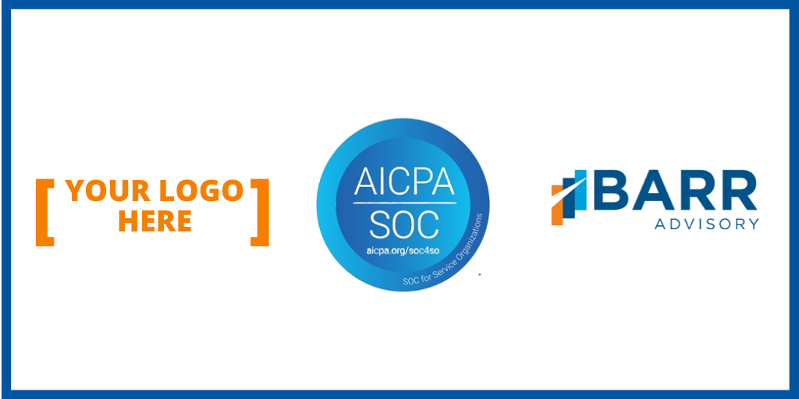](https://www.barradvisory.com/wp-content/uploads/2023/08/SOCPromoPackage_Image5_Landscape.png)